Name: Shivani Suresh

Register Number:2021503050

Semester:5

Batch:2

Course: CS6111- Computer Networks

Lab - Experiment 10 – Stop and Wait

**Code:**

**Sender:**

import java.io.*;

import java.net.*;

public class Sender {

Socket sender;

ObjectOutputStream out;

ObjectInputStream in;

String packet, ack, str, msg;

int n, i = 0, sequence = 0;

Sender() {}

public void run() {

try {

BufferedReader br = new BufferedReader(new InputStreamReader(System.in));

System.out.println("Waiting for Connection....");

sender = new Socket("localhost", 2005);

sequence = 0;

out = new ObjectOutputStream(sender.getOutputStream());

out.flush();

in = new ObjectInputStream(sender.getInputStream());

str = (String) in.readObject();

System.out.println("reciver > " + str);

System.out.println("Enter the data to send....");

packet = br.readLine();

n = packet.length();

do {

try {

if (i< n) {

msg = String.valueOf(sequence);

msg = msg.concat(packet.substring(i, i + 1));

} else if (i == n) {

msg = "end";

out.writeObject(msg);

break;

}

out.writeObject(msg);

sequence = (sequence == 0) ?1:0;

out.flush();

System.out.println("data sent>" + msg);

ack = (String) in.readObject();

System.out.println("waiting for ack.....\n\n");

if (ack.equals(String.valueOf(sequence))) {

i++;

System.out.println("receiver > " + " packet recieved\n\n");

} else {

System.out.println("Time out resending data....\n\n");

sequence = (sequence == 0) ?1:0;

}

} catch (Exception e) {}

} while (i< n + 1);

System.out.println("All data sent. exiting.");

} catch (Exception e) {} finally {

try {

in.close();

out.close();

sender.close();

} catch (Exception e) {}

}

}

public static void main(String args[]) {

Sender s = new Sender();

s.run();

}

**Receiver:**

import java.io.*;

import java.net.*;

public class Receiver {

ServerSocket reciever;

Socket connection = null;

ObjectOutputStream out;

ObjectInputStream in;

String packet, ack, data = "";

int i = 0, sequence = 0;

Receiver() {}

public void run() {

try {

BufferedReader br = new BufferedReader(new InputStreamReader(System.in));

reciever = new ServerSocket(2005, 10);

System.out.println("waiting for connection...");

connection = reciever.accept();

sequence = 0;

System.out.println("Connection established :");

out = new ObjectOutputStream(connection.getOutputStream());

out.flush();

in = new ObjectInputStream(connection.getInputStream());

out.writeObject("connected .");

do {

try {

packet = (String) in.readObject();

if (Integer.valueOf(packet.substring(0, 1)) == sequence) {

data += packet.substring(1);

sequence = (sequence == 0) ?1:0;

System.out.println("\n\nreceiver >" + packet);

} else {

System.out.println(

"\n\nreceiver >" + packet + " duplicate data"

);

}

if (i<3) {

out.writeObject(String.valueOf(sequence));

i++;

} else {

out.writeObject(String.valueOf((sequence + 1) % 2));

i = 0;

}

} catch (Exception e) {}

} while(!packet.equals("end"));

System.out.println("Data received=" + data);

out.writeObject("connection ended .");

} catch (Exception e) {} finally {

try {

in.close();

out.close();

reciever.close();

} catch (Exception e) {}

}

}

public static void main(String args[]) {

Receiver s = new Receiver();

while (true) {

s.run();

}

}

}

**Output:**

**Sender:**

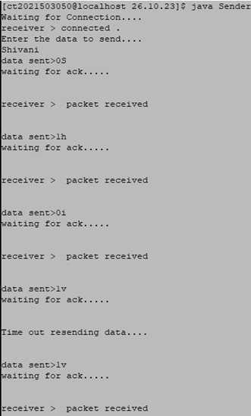

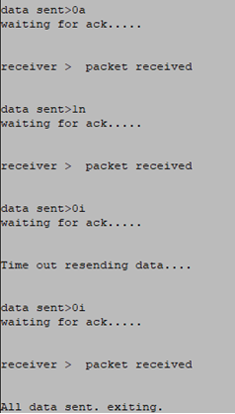

**Receiver:**

